# Guide

Contents

Guide 1

Tools 2

Figure 1 2

Design Pattern 2

How to Run the Project 2

Figure 2 3

## Tools

I have created this Project in Visual Studio 2017 with selenium web driver using C# so please open the solution file using VS 2017. I have used NUnit as testing framework. I have worked with Chrome web driver and the version of Chrome at my end is 83. So make sure to take a look at the version of Chrome at your end prior to running the solution.

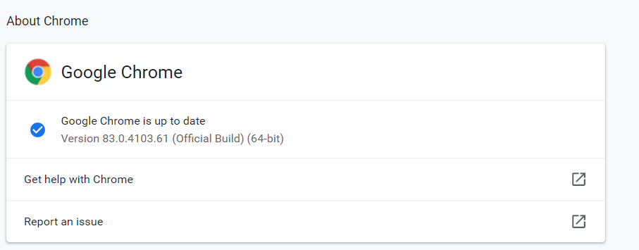

### Figure 1

## Design Pattern

I have created this project using page object design pattern in which every screen has its own partial classes of elements, actions and assertions. Element classes contains elements of all the corresponding pages, Action classes contains the actions of that class and assertion possessed the assertions used for that page.

After every action and assertion, I am returning the resultant class against that action and assertion and passing web driver in the corresponding constructor of that class. This will enable the tester to write the automation test as rapid as possible and he/she just need to add “.” After every action or assertion, suggestions will prompt him/her to do next thing. I have tried to make name of functions and assertions as meaningful as I could but there is obviously room of a lot of improvement.

I have created a HelperFunction class which contains all the helper function I needed to make this project work.

## How to Run the Project

It is a test project so you will see a Test Explorer on left side of VS as shown in below figure. Right click on any of the test case and run it. It will run independently from each other. While running TestCase2, the address of user will be changed so you have to revert it back to the original address which I am using in TestCase1. Otherwise, test cases will start failing in asserting the original address with the changed one.

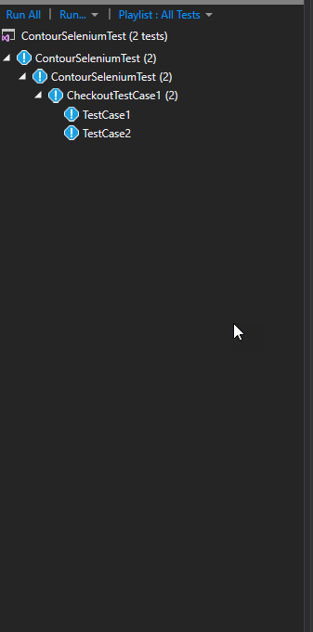

### Figure 2